# SQL for Devs Midterms

## Instructions:

* **Read the instructions properly**
* Referring to notes and online resources are allowed
* You may compile your answers in a single or multiple files
* For reference, Database diagram is included at the last page
* You are given a week to answer the questions upon receiving this file and late submission will strictly NOT be considered.

**Due: 11:59PM May 28, 2022**

* Email the proctors (Francis, Regie and Catherine) once your answers are checked-in on the code repository.
* No class session on Monday, Wednesday to give way for the Exam
* Feel free to reach out to the proctors if you have any questions

1. Write a script that would return the id and name of the store that does NOT have any Order record (1 pt).
2. Write a script with the following criteria (4 pts):
   1. Query all Products from Baldwin Bikes store with the model year of 2017 to 2018
   2. Query should return the following fields: Product Id, Product Name, Brand Name, Category Name and Quantity
   3. Result set should be sorted from the highest quantity, Product Name, Brand Name and Category Name

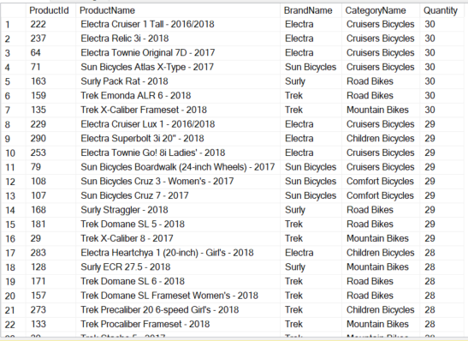

1. Write a script with the following criteria (3 pts):
   1. Return the total number of orders per year and store name
   2. Query should return the following fields: Store Name, Order Year and the Number of Orders of that year
   3. Result set should be sorted by Store Name and most recent order year

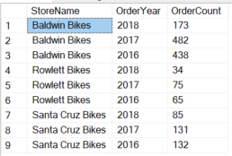

1. Write a script with the following criteria (4 pts):
   1. Using a CTE and Window function, select the top 5 most expensive products per brand
   2. Data should be sorted by the most expensive product and product name

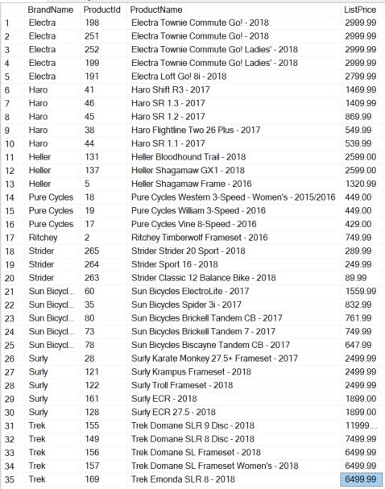

1. Using the script from #3, use a cursor to print the records following the format below (3 pts):

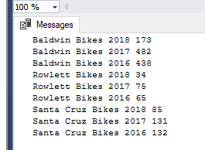

1. Create a script with one loop is nested within another to output the multiplication tables for the numbers one to ten
   1. Sample Result:

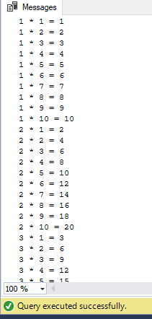

1. Create a script using a PIVOT operator to get the monthly sales
   1. Use Sales.SalesOrderHeader table
   2. Sample Result:



**DATABASE DIAGRAM**

